**930923716**

Agreement url:   
http://www.zgmfskin.com

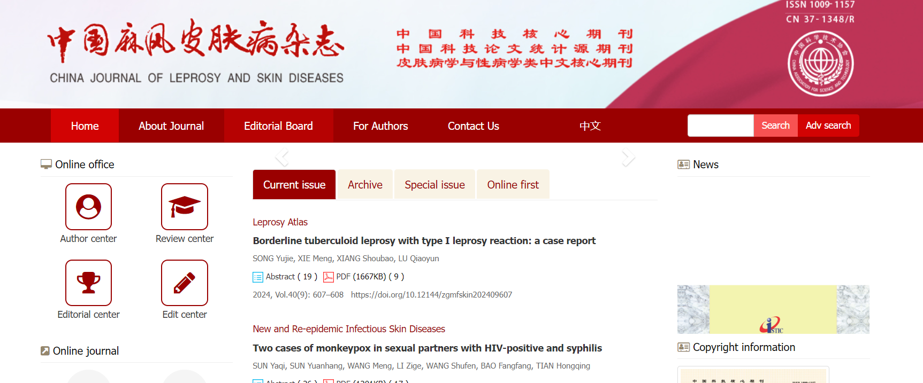

Select English Version

Current issue

Year

Volume

title

Issue

Download the pdf

DOI

Page range

* **In here both English and Chinese toc needs to be captured**

**In here as per the issue pattern we can determine the month pattern.**

**Example issue is 8 Month is August , if issue is 9 month is September.**

**But operator always needs to check in meta data capturing.**